Dear Parent/Guardian/Student
In partnership with the Office of Traffic Safety, California Highway Patrol, Impact Teen Drivers, and San Juan Hills High School, all students wishing to purchase a parking spot for the 2023-2024 School Year must complete an online educational module on California’s Graduated Driver Licensing Law. We are requiring parents and students to complete the module and the mandatory survey together. This online module will increase the understanding of the risks of teen driving, help protect teen drivers and passengers, and provide a comprehensive understanding of the California Graduated Driver Licensing Law. The module outlines elements of California’s Graduated Driver Licensing, including Passenger Limits, Night-Time Driving, Mandatory Seat Belt Use, and No Electronic Devices.

IMPORTANT: The module takes approximately 25 minutes to complete. Impact Teen Drivers is not responsible for showing proof of completion. Students and parents are responsible for showing proof of completion to their school after participating in the module. At the end of the module, there is a mandatory survey. Upon completing the survey, the Learning Management System will provide a Certificate of Completion to download.

To access the GDL module, use the following link:
CLICK HERE TO TAKE THE REQUIRED CALIFORNIA GDL MODULE

Tips on how to navigate the online educational module
- The module can be accessed on a desktop, laptop, smartphone, or tablet.
- Make an account on modules.impactteendrivers.org.
- When making your account, you will be asked to make a profile with some basic information. When making your profile, use our school’s ZIP code in the School Affiliation section. Our school’s ZIP code is: 92675
- A dropdown menu will appear for School County and School Name, choose our county (Orange County) and our school name. Please make sure to choose our school when making your profile!
- Choose the California Graduated Driver Licensing (GDL) Module.
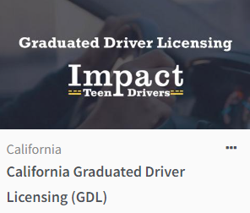
- Complete the Module and the mandatory Survey.
- Upon completing the Survey, the Learning Management System will provide a Certificate of Completion to download or print. Log back into your account at any time and choose California GDL Module to re-print your Certificate.

